DIRECT TORQUE CONTROL WITH FEEDBACK LINEARIZATION FOR INDUCTION MOTOR DRIVES
ABSTRACT
This paper describes a direct-torque-controlled (DTC) induction motor (IM) drive that employs feedback linearization and sliding-mode control (SMC). A new feedback linearization approach is proposed, which yields a decoupled linear IM model with two state variables: torque and stator flux magnitude. This intuitive linear model is used to implement a DTC-type controller that preserves all DTC advantages and eliminates its main drawback, the flux and torque ripple. Robust, fast, and ripple-free control is achieved by using SMC with proportional control in the vicinity of the sliding surface. SMC assures robustness as in DTC, while the proportional component eliminates the torque and flux ripple. The torque time response is similar to conventional DTC and the proposed solution is flexible and highly tunable due to the P component. The controller design is presented, and its robust stability is analyzed in simulations. The sliding controller is compared with a linear DTC scheme with and without feedback linearization. Extensive experimental results for a sensorless IM drive validate the proposed solution.

BLOCK DIAGRAM FOR PROPOSED SYSTEM
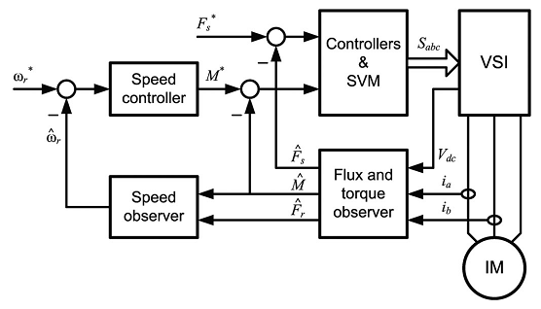
Fig. 1. Block diagram of the sensorless DTC IM drive with feedback linearization.
DESIGNG SOFTWARE AND TOOLS:
MAT LAB /SIMULATION Software and simu power systems tools are used. Mainly control system tools, power electronics and electrical elements tools are used.

